Intershape studios 7 days for £7.00 voucher
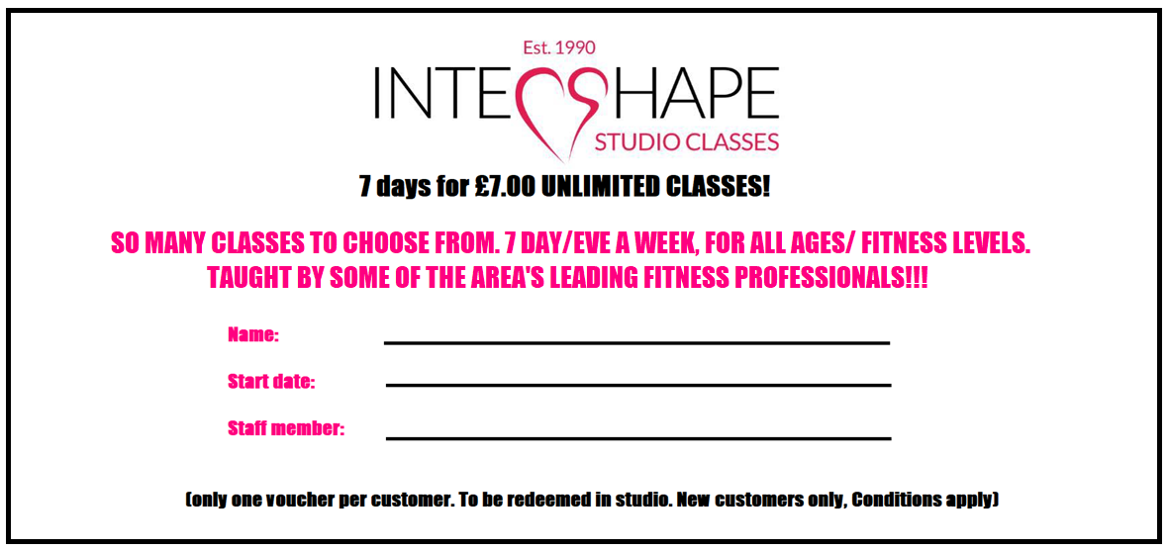

Print me out and hand over to staff member on reception & enjoy!

